Coreopsis – The Preferred Name for a Preferred Plant
The common names of plants are invariably the names we prefer since they are in a language that makes sense and is easy to recall. Typically, the biggest challenge with common names is the lack of consistency, as they can vary from one location to another even within the same state. A smaller, yet still problematic challenge is the lack of sales appeal some common names embody. For example, Tickseed is the accepted common name for the genus Coreopsis. Coreopsis is a wonderful genus of garden worthy flowering plants, yet having a common name associated with a feared insect can drive gardeners in search of alternatives.
Coreopsis is a member of the Asteraceae or Sunflower family with 75-80 species stretching from North America south into Mexico and South America. The genus name was crafted by Carl Linnaeus (1707-1778) in 1753 from the Greek Koris meaning bug and Opsis meaning like. Yes, even the botanical name references an insect! It is indeed fortunate that most gardeners do not understand Greek. The botanical and common names stem from the loose resemblance of the seed, technically a dry fruit called an achene to that of an insect or tick.
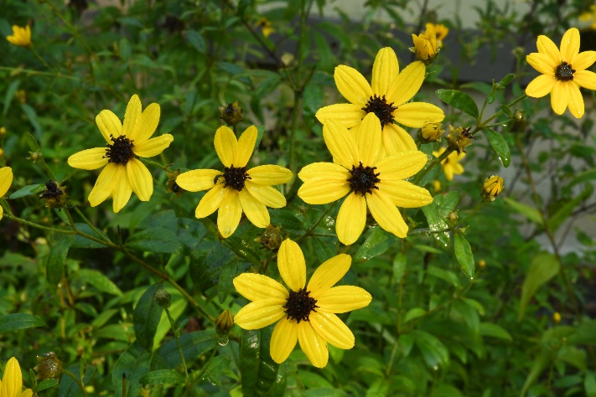
When I was first starting to learn plants, the most commonly available species was Coreopsis grandiflora, the Large Flowered Tickseed. The English botanist and florist, Thomas Hogg (1777-1855) is credited with naming the plant, but he failed to adequately describe the plant. It was properly described in 1826 by the English botanist and Horticulturist Robert Sweet (1783-1835). The challenge I faced with this plant was not the ‘bug oriented’ name, but its relatively short lifespan. Growing from 1-2’ tall, this species and its cultivars produces copious displays of flowers over narrow, pinnate foliage. It should be noted that in the Asteraceae, what appears as a single flower is actually 50 or so small flowers called florets that are perched on a platform called a capitulum (as pictured at right with Coreopsis tripteris). The scentless flowers of Coreopsis grandiflora are 2-2 ½” in diameter with an outer whirl of what appears to be 6-12 yellow petals. In reality, each of the yellow ‘petals’ is an individual flower called a ray floret. These, in turn surround a center boss of golden yellow disc florets. Botanically speaking, all the petals of a flower are collectively called a corolla and for the central disc florets the corolla is greatly reduced in size, with the individual petals fused to create a small bristly tube. The corolla of the outer ray florets produce a tongue-like extension that projects outward from the flower head, looking like a conventional petal of a flower. The benefit to this flower structure is the great abundance of seeds that can be produced. Unfortunately, production of seed also requires a lot of energy, shortening the lifespan of certain Coreopsis species to a few years, especially if planted in heavier, moister soils. Prodigious seed production is a culinary benefit to several bird species, like Goldfinches and may lead to ample and perhaps unwanted self-sowing.
Coreopsis verticillata, the Whirled Tickseed has proven to be a far longer lived species and actually spreads slowly via a rhizomatous root system to form a respectable groundcover. This species is predominantly found in dry open woodlands from Maryland south to Georgia, although populations have been found as far west as Oklahoma and as far north as Quebec and Ontario. The plants consist of closely spaced, slender upright stems to 2-3’ tall that are clothed with very narrow, oppositely arranged foliage. Each leaf is actually divided into 3 narrow leaflets, each approximately ⅛” wide by 2-3” long, giving the plant a very fine textured appearance. The stems are crowned by clusters of 2” golden yellow flowers, opening from late June through early September.
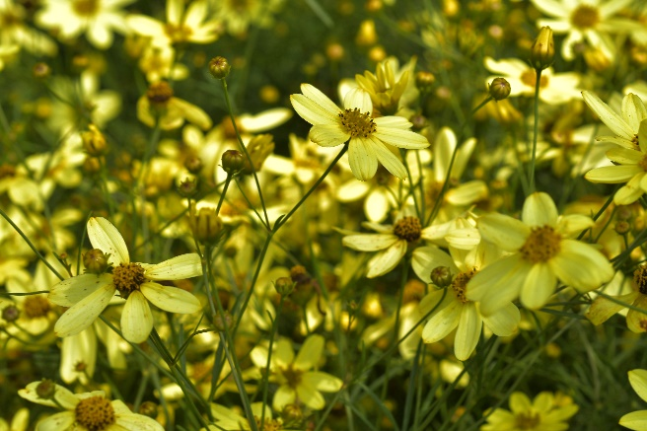
The most popular cultivar of this species and undoubtedly the most puzzling is Coreopsis ‘Moonbeam’. It is a chance seedling of unknown parentage that mysteriously began appearing randomly at nurseries during the 50’s and perhaps even earlier. A rosarian, author and gardener by the name of Léonie Bell who lived near the town of Conshohocken PA, acquired a plant around 1960 from a neighboring gardener, Mr. Howard Chidester. He, had acquired the as yet unnamed plant from a Farm Stand outside of Toms River, NJ. Léonie Bell shared a division with Donald Allen of Barre Vermont, who operated a rock garden nursery named Sky-Cleft Gardens. Highly impressed, he quickly propagated enough of the plant to offer it in his 1965 catalogue. When he asked Léonie what it should be named, she simply wrote back “Oh, something with moon in it” to honor the pale yellow flower this plant produces, and in 1965 ‘Moonbeam’ was born! Oddly, the plant still remained relatively unknown and in the shadows. Fast forward to the 1980’s. Dr. Nicholas Nickou, a medical doctor and famed horticulturist in Branford Connecticut received a plant from Edward Alexander, a taxonomist at the NY Botanic Garden. Dr. Nickou in turn shared it with his good friend, author and nurseryman Fred McGourty in Norfolk Connecticut. Fred promoted it at his nursery, Hillside Gardens and actively distributed it to the nursery trade. From this point forward it finally claimed its fair share of the spotlight and was named the Perennial Plant of the Year in 1992!
‘Moonbeam’ is sterile and since it yields no seed, it blooms unabated from June through September. Unlike the species selections of Coreopsis verticillata, Moonbeam does not have rigid, upright stems. Rather, by midsummer, the plant develops a gracefully mounding habit to 18” tall and somewhat wider. The foliage is a rich dark green and very slender, almost needlelike although it is soft to the touch. To top it off, the pale yellow flower color readily blends with nearly any neighboring color, makes this is a true garden winner! It really makes one wonder why it took so long to gain its notoriety! The one drawback is the shortened life span when located in rich, moist soils. The plants prefer well-drained gritty soils with a lower fertility and I have known of plants that have lived for years under such conditions. Although often listed under the species verticillata, it is actually a cross, perhaps with Coreopsis rosea f.leucantha or Coreopsis tripteris. The true story of its parentage will probably never be known.
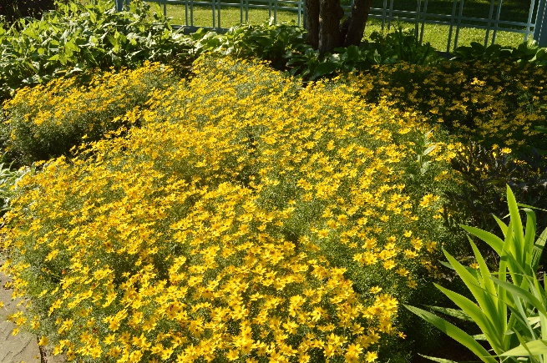
Another outstanding selections is ‘Zagreb’ (pictured at left). It was introduced in 1997 from, oddly enough, the Department of Ornamental Plants and Landscape Architecture at the University of Zagreb, in Zagreb Croatia. It is a very compact plant, growing to 1’ tall and slowly spreading via the rhizomatous roots to 3’ in diameter over 10 years. It makes a very effective and weed free groundcover. The 1-2” diameter flowers are golden yellow with slightly darker central disc florets, while the foliage is a lighter green than its cousin, ‘Moonbeam’. Both this species and Coreopsis grandiflora flourish best in full sun and well-drained, gritty soils. Even after the flowers fade in September, the dark seed heads against the light yellow foliage prove ornamental (pictured below at the end). Wet soils, especially during the winter will compromise the health of the plants, often resulting in plant loss if exceptionally moist.
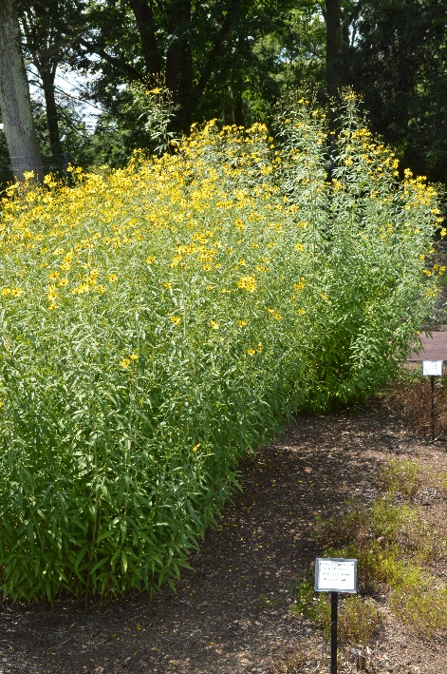
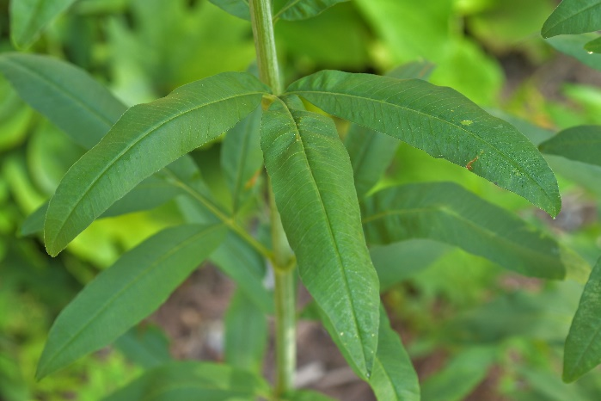
Unlike the previous two species, Coreopsis tripteris is a far taller species and in my opinion, far too little seen in gardens. Commonly called Tall Tickseed based on its 3-8’ tall stature (as seen at right), this species also differs from its cousins by naturally growing in moist meadows and along streams. Also unlike its cousins, the flowers are sweetly scented and the foliage often assumes attractive red and auburn fall colors. The plants are native from Florida west to Texas, north to Ontario and Quebec. Named by Linnaeus in 1753, the species epithet is a mix of the Latin Tri for three and Pterus for wing or feather. It refers to the appearance of the foliage, which is divided into 3 or 5 narrow leaflets of up to 5” long by ¾” wide that resemble feathers (pictured below). The foliage has a light fragrance of anise, which may deter deer browse where pressure is light. The 1½-2” diameter flowers yield a very long display, starting in late July and continuing well into September. They are arranged in an open cyme configuration, whereby the flower of the central stem or peduncle opens first, followed by the flowers of the lower and very well branched peduncles. Each cyme is usually around 12” in diameter. This creates a more ethereal appearance than the previous two species, which have a far denser floral display. The flowers have clear yellow ray florets and brown disc florets with red or purple overtones (pictured at the start of the article). In soils that are moisture retentive yet drain well, the plants average 4-5’ in height and the stems remain sturdy. If overly fertilized or if the soil remains too moist, plant heights may stretch to 8’, often resulting in the plant collapsing. The plants are known to freely seed about the garden and certain sap-sucking beetle-like insects can be problematic some years in June as they converge around and kill the youngest growth. In the garden, they can be mixed with taller ornamental grasses and can provide attractive seasonal screening. If placed next to a path or a patio the sweet scent of the flowers can also be appreciated – what could be better?
There are obviously, many more species and cultivars for gardeners to consider, including some that also feature pink and bicolor flower. However, the species and selections mentioned herein will provide a variety of heights, textures, fragrance and even a touch of historical mystery, allowing the summertime garden to come alive. Yes, the common name may not conjure up images of beauty, but Coreopsis is indeed a plant of great beauty and merit for the Garden.
Special Note: I would like to thank Ms. Carol Hanby, Dr. Nicholas Nickou’s longtime friend and partner and Ms. Julie Arriens, Dr. Nickou’s daughter for the information relating to the history of Coreopsis ‘Moonbeam’.
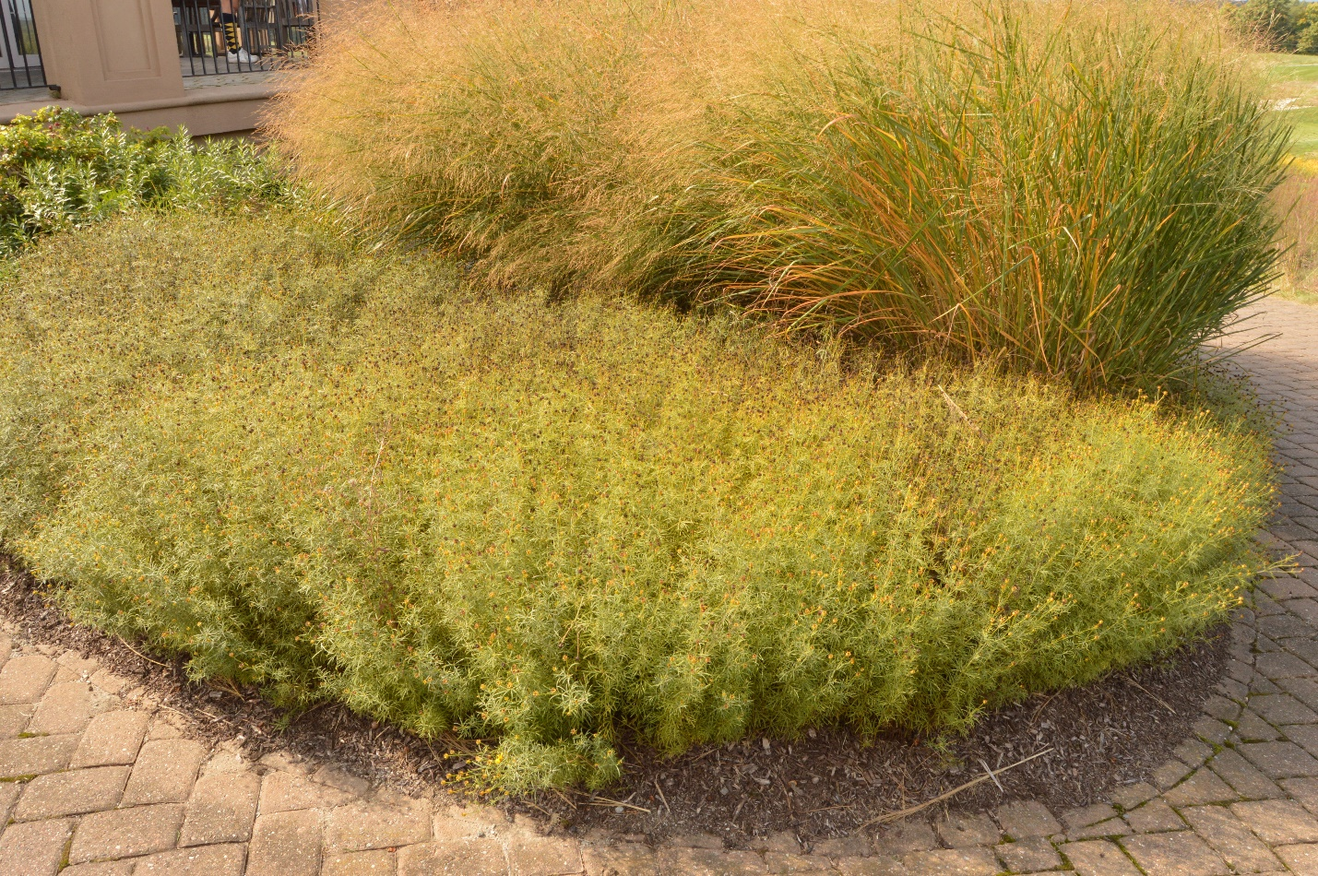
Bruce Crawford
Program Leader in Home and Public Horticulture, NJAES

