The Story of the Beautiful Dove

Like people, every plant has a story a story to tell. Sometimes the stories are romantic, sometimes funny and at other times boring, but there is always a story. Unfortunately, plants are challenged at relaying their story. Many a time I have stood in front of a plant with a phenomenal tale to tell, only to walk away none the wiser. The Dove Tree is one such plant. There is a beautiful specimen at Rutgers Gardens which I have admired for years; its flowers, form and bark are both interesting and attractive. However, it never mentioned its interesting tale of how it was introduced into gardens and commercial horticulture!

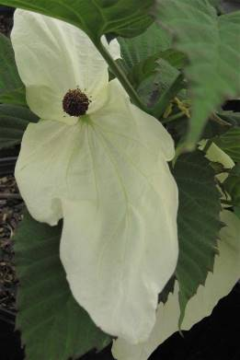
Dove Tree is botanically named Davidia involucrate, and is a member of the Nyssaceae or Tupelo Family. The genus name honors Father Armand David (1826-1900), a French missionary who was also an avid naturalist, possessing a deep interest in both plants and animals. Between1862 and 1873, David undertook several expeditions into China and Mongolia and among the several hundred ‘discoveries’, he was the first European to see and describe Panda Bears and the Dove Tree. The tree was first found near the Tibetan border of China with the first botanical description published in 1871 by the French physician and botanist Dr. Henri Ernest Baillon (1827-1895). However, he described the plant from dried specimens, as there was yet to be a living plant in Europe. Many years later, the Scottish physician and botanist Augustine Henry (1857-1930) travelled to the remote village of Ichang in Hubei Province, searching for medicinal plants. During his expeditions, he found a single specimen of Davidia in 1887, but the samples and seed of the plant were lost in route back to Europe. The competition to acquire new introductions from abroad was fierce during this time; wishing to be the first to have this elusive plant, the nursery of James Veitch and Sons nursery hired Ernst H Wilson (1876-1930) to find the tree that Henry had seen and to send back seed. After a long and arduous journey, Wilson arrived at the site of Henry’s tree, only to find a stump. Evidently, some members in the community found the lumber better suited for constructing a homestead than for enjoying its ornamental attributes! Undaunted, Wilson continued his trip, eventually finding more specimens near the location where David first discovered the plant. The seed finally arrived back on English soil in April 1902. Interestingly, the story does not end here, since this turned out to not be the first seed to reach Europe. Unbeknownst to Veitch, in 1897 the French missionary and botanist Père Farges (1844-1912) sent back seed from China to Maurice L. de Vilmorin, a wealthy landowner in France. Of the 37 seed he sent back, one reluctantly germinated in June of 1899, the same time that Wilson was just arriving on Chinese soil! This seedling was distinctly different from the plants that Wilson brought back, since it had pubescent or lanate foliage rather than smooth. The plant was given the varietal status of var. Vilmoriniana in recognition of its physical differences. There has been much debate as to whether or not this plant is worthy of simply varietal status or should become a separate species. Wilson thought the two forms were unique, but also noted that the two forms comingled in their native populations. Today, this variety is a bit more common than the forms with glabrous leaves and it also appears to be slightly hardier, tolerating zone 5 winters as opposed to zone 6.

Was the effort and money spent a worthwhile investment? Most certainly! For most gardeners, the main interest lies in the unique flowers that appear along with the leaves in May. The species epithet of involucrata refers to an involucre, which is a flower surrounded by one or more bracts located closely behind the flower. For Davidia, the flower is subtended by two large white bracts of unequal size (as pictured above, photo credit Lisa Strovinsky). It is not uncommon for the larger of the two bracts to reach 6-7” long and 4” wide, while the smaller is 3-4” and 2” wide. From a distance, the dangling bracts literally give the appearance of rows of white Doves perched among the tree’s branches. For other individuals, the bracts give the appearance of dangling white handkerchiefs, giving rise to the other common name of Handkerchief Tree. Within the two bracts is a ¾” sphere of red-tipped anthers, looking all very much like a very spiky little sputnik. The appearance of the flowers also coincides with that of the leaves, and the bracts often become overlooked, especially as the tree grows taller. However, when they fall and carpet the ground in late May and early June, the flowers add a new and dramatic dimension to the garden – an often overlooked attribute that really brightens the garden floor. The biggest issue with the flowers is waiting for the tree to mature to the age of flowering. Often, the gardener will wait 10-20 years before flowering begins. Recently, a new selection has appeared on the market named ‘Sonoma’ that blooms as a very small tree and is well worth seeking out.

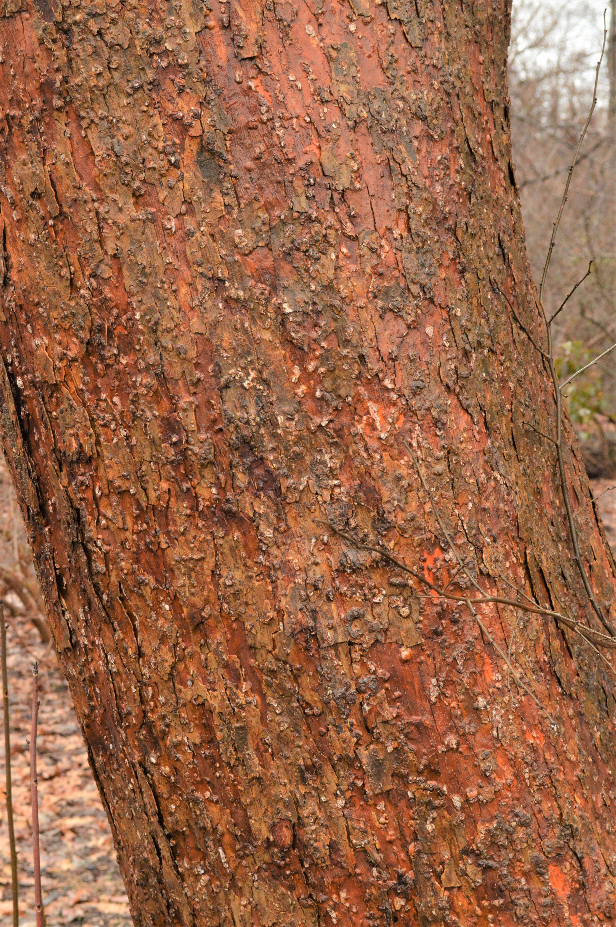
Aside from the floral interest, Davidia is an attractive tree with a pyramidal habit that gradually becomes rounded with time. The dark green foliage has a pleasingly coarse texture with a purple blush when unfurling. There is no fall color of note, but the platy orange bark (as seen on the right) provides an attractive winter detail, especially if there is an evergreen background. Many gardeners consider Davidia to be a small tree, but it can reach 50’ and greater with time. For me, its form and bark are reason enough to grow this plant! Provide the plant with a well-drained, humus rich soil in full sun or light shade and the plant will reward you with upwards of 2’ of growth per year when young. Although some may think that 10 or more years to flowering is a reason to avoid this plant, its graceful habit, ease of growth, warm bark and interesting stories are all very compelling reasons why more gardeners should invite this beautiful dove into their garden.

Bruce Crawford
Rutgers Gardens

