Diervilla – No Codling Required
I have long concluded that plants requiring little to no attention are often overlooked in favor of those dependent upon your endless care and codling. The first time I was introduced to Northern Bush Honeysuckle, botanically known as Diervilla lonicera, was around 1990. It was growing in a public garden that was in serious need of care. With weeds growing lushly through the surrounding shrubs, the Diervilla stood weed free, with its glossy foliage and dense arching branches looking very attractive. Here was a plant that was serving the garden well without any coddling and yet I had never heard of it before. For all those gardeners who have also not heard of this plant, let me introduce you!
Diervilla is a member of the Caprifoliaceae or Honeysuckle family. Although a large family with over 860 species, Diervilla is a small genus with only 3 species, all native to Eastern North America. The plant was named by the French botanist Joseph Pitton de Tournefort (1656-1708) in 1706 in honor of Sieur de Dièrville, a French medical doctor and botanist. Tournefort worked at the Jardin Royal Des Plantes and received funding to commission Dièrville to explore Acadia in search of new and potentially beneficial plants. Acadia was a region of North America that contained present day Nova Scotia, Prince Edward Island, New Brunswick Canada and a portion of Maine. Dièrville scouted the area from October 1699 through October 1700 and returned with numerous plants, including what would ultimately be named Diervilla lonicera. In 1753 the Swedish botanist Carl Linnaeus (1707-1778) partially adopted Tournefort’s honorary name by mistakenly naming the plant Lonicera diervilla. It was not until 1768 that the plant was properly named by Phillip Miller ((1691-1771) in the 8th edition of his well respected work entitled The Gardeners Dictionary. Lonicera is the botanical name for the genus Honeysuckle and the species epithet along with Linnaeus’s misnaming describes how closely the plant resembles a shrubby Honeysuckle.
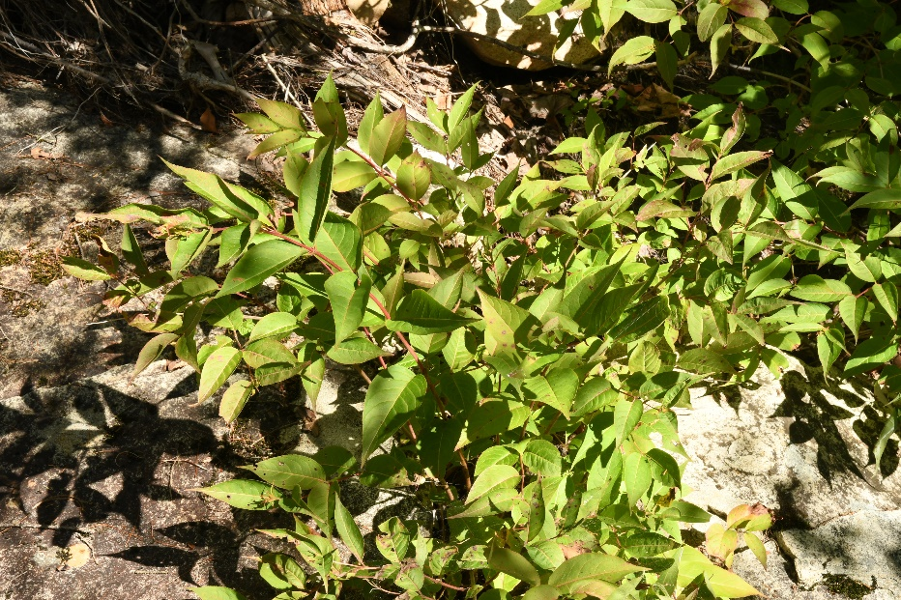
Without doubt, Northern Bush Honeysuckle is one tough plant! It is native from Quebec west to Saskatchewan, south into the mountains of Alabama and Georgia. Growing to 2-3’ tall and spreading wider with time, the 2-6” long by 1-3” wide foliage is glossy green with the new foliage often washed with a blush of orange. The leaves are finely serrate or toothed and are attached to the stem via a short petiole. In the wild it grows in well-drained rocky areas in full sun or light shade. I was actually able to witness its ironclad constitution while hiking at Franconia Notch in NH; I saw several plants growing from a rock fissure in the dry edges of a stream bed and it looked perfectly content (pictured above right). From late June through July, the plants produce clusters of sulfur yellow, 5 petaled trumpet shaped flowers at the tips of the arching stems that are frequented by bumblebees and other pollinators. The flowers are individually ½” long and wide and appear as an aggregate of cymes measuring 2-3” in diameter. A cyme is a group of flowers with a central stem, whereby the apical flower blooms first followed by the lateral flower. The flowers are self-incompatible and require the presence of a genetically different plant for seed production, which are greedily devoured by several bird species come the fall.
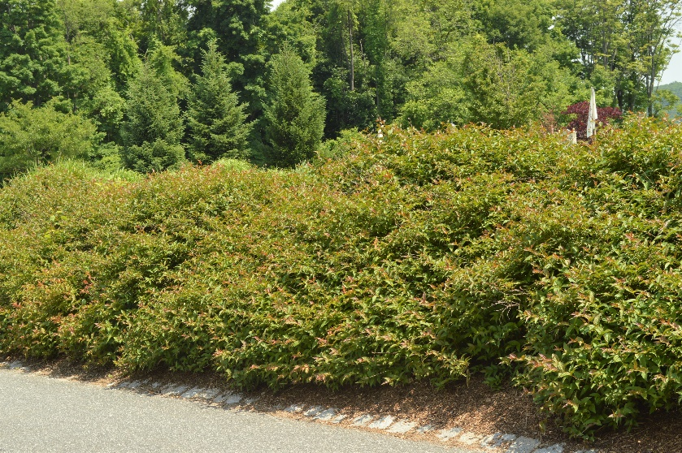
The tried and true selection named ‘Copper’ has copper-red colored new growth that continues to appear throughout the summer, followed by bronze and red fall color. It has performed very admirably in one garden I have visited, as seen at right during June. There it serves as a groundcover on a hot, westerly oriented slope where it not only prevents soil erosion, but also suppresses weed growth!
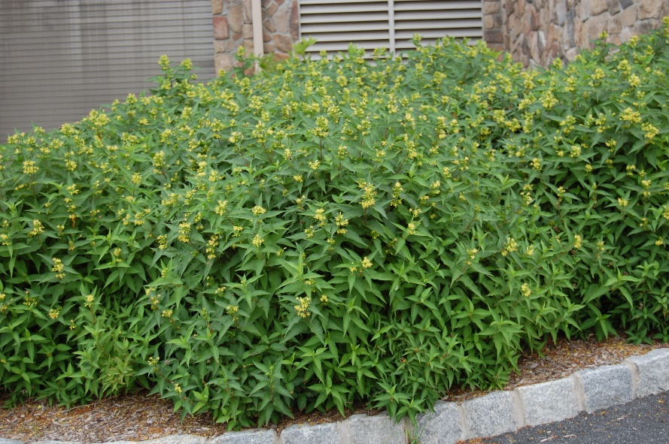
Southern Bush Honeysuckle, Diervilla sessilifolia is very similar to its Northern Cousin. As the common name denotes, its natural populations are far more southern, growing in the Appalachian and Great Smokey Mountains of Alabama and Georgia north into Tennessee and N. Carolina, where it is found growing along stream banks, on dry slopes and ridges and at the edges of woodlands. The species was identified and named in 1843 by Samuel Botsford Buckley (1809-1884), who focused on plants and geology throughout the southern United States. The distinctive difference between this species and the former is the lack of a petiole or ‘leaf stalk’ for Southern Bush Honeysuckle, as the foliage is connected directly to the stem. Botanically, this form of leaf attachment is termed sessile and is the obvious inspiration for the species epithet. Like its cousin, this species is equally at home in sun and shade, although it will grow taller with adequate sun and moisture. The yellow flowers are nearly identical and the nectar is just as sweet should you decide to draw it out of the flower. The flowers and its nectar are also popular with Bumble Bees. The selection called ‘Butterfly’ (pictured above in flower during late June) has glossy green foliage on red stems and come fall, the foliage often assumes attractive shades of a dusky red, even in shadier locations (as pictured at the end of the article).
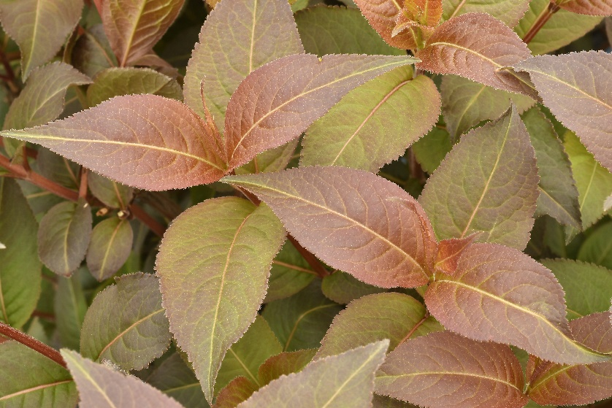
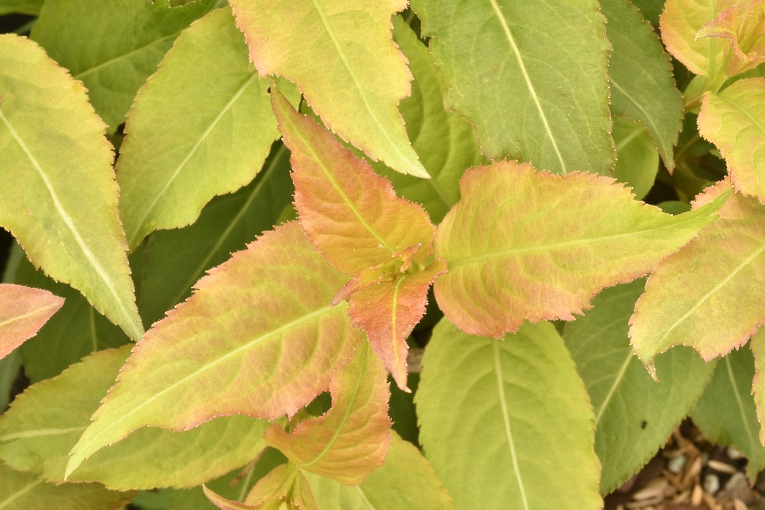
Considering how close the two species are genetically, it is only natural for them to cross where the natural populations overlap. In 1853, the French botanist Élie-Abel Carrière (1818-1896) noted the crosses and named them Diervilla x splendens. A number of new selections have been recently released from select interspecific crosses, including Kodiak® Red and Kodiak® Orange (Kodiak® Orange is pictured at left), as well as Firefly™ Nightglow™. Kodiak® Orange and Red display new growth and fall color in the respective colors of their name, while Firefly™ Nightglow™ (pictured on the right) has a deeper red foliage color throughout the growing season, against which the golden yellow flowers glow. Kodiak® Orange appears to be the favorite from professionals with whom I have spoken. The foliage is certainly both full and very cheerful to see in the Garden throughout the season!
Growing in similar areas as Southern Bush Honeysuckle, but only in higher elevations is the last species of Diervilla, Diervilla rivularis. Known as Mountain Bush Honeysuckle, it is very similar to its southern cousin, differing mostly by the presence of dense pubescence on the leaf undersides and stems that allow it to survive the cold, mountainous elevations. The species epithet is from the Latin meaning of small brooks or rivulets and was named in 1888 by the German born botanist and doctor, Augustin Gattinger (1825-1903) who extensively studied the flora of Tennessee. Found growing on rocky ridges, slopes and moist open woodlands by streams, it is not as common in the trade as the other species and crosses. However, this may change with the recently introduced selection named Kodiak® Black, which features dark bronze colored new growth
The plants have certainly proved to be more than adequately winter hardy, with Northern Bush Honeysuckle enduring zone 3 winters and the remaining forms surviving zone 5 (4). They provide dense, weed proof ground covers for locations in beating sun or shade and are tolerant of rocky, dry soil conditions or moist streamside! Although they may be eaten by deer, or worse yet moose during the winter, they readily reshoot and produce attractive yellow flowers for over 2 months above clean green and copper flushed foliage throughout the summer. With so many plants requiring codling from late frosts, insects or protection from encroaching weeds, it is time to give attention to a plant providing great beauty while asking nothing in return!
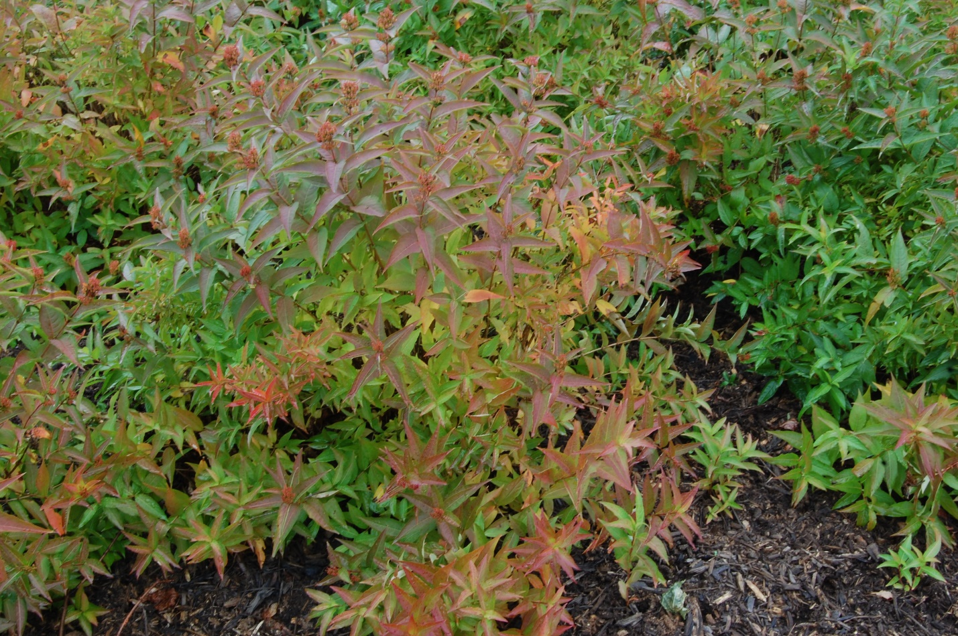
Bruce Crawford
State Program Leader in Home and Public Horticulture (NJAES)

