Solomon’s Seal – ‘Knee Deep’ in Garden Applications
As a gardener, I am always searching for interesting, low growing plants to incorporate into designs. A garden will have more depth and visual interest if the lower levels, typically home to herbaceous plants, do not all mature to the same height. Rather, it is best if they mature from ground hugging to knee height. As one might suspect, it is the ground hugging forms that are the most challenging to find, especially forms that do not spread uncontrollably. For years, I have seen Dwarf Solomon’s Seal, botanically known as Polygonatum humile for sale at specialty garden centers and did not appreciate its garden worthiness until seeing it in a woodland garden!
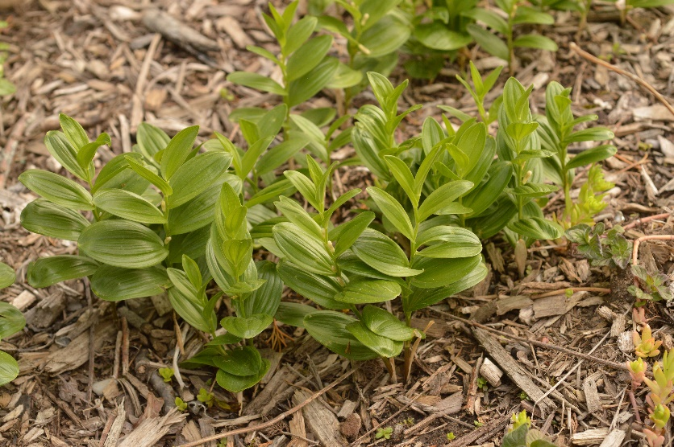
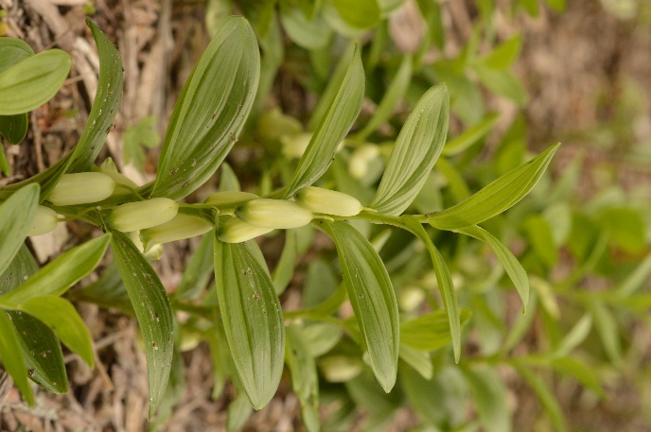
Polygonatum is a member of the Asparagaceae or Asparagus Family with approximately 63 species located in the northern hemisphere, mostly in Asia. The genus name was crafted in 1754 by the English Botanist and Head Gardener for the Chelsea Physic Garden, Philip Miller (1691-1771). It is from the Greek, merging Poly for many and Gonu for knees and is a reference to the zig-zag shape of the creeping rhizome which produces an angular, knee-like joint between the growths from each season. The species epithet was ascribed and the plant initially described by the Russian Botanist and plant collector Carl Johann Maximovich (1827-1891) who most likely collected this plant in Asia. However, it was his botanical coworker at the Saint Petersburg Botanical Gardens, Friedrich Ernst Ludwig von Fischer (1782-1854) who properly described the plant and was posthumously ascribed as the author in 1859. Humile is Latin for low and it certainly well describes the 6-8” height of this plant as seen above, especially when compared to the other, far taller species within this genus. The common name of Solomon’s Seal is believed to have originated from the shape of the leaf scar on the rhizome; it resembles the two overlapping triangles that constitute the Seal of King Solomon.
Dwarf Solomon’s Seal is actually native to a broad area of Asia. It is found in forests and grassy slopes in NE China, Japan, Korea and E Siberia. Despite its shorter statue, the ovate to lance shaped leaves are nearly the same size as its larger cousins, reaching 3” long. The foliage is an attractive glossy green, featuring deep parallel venation and leaf bases that clasp the stem. The upper leaves are curiously cup shaped, while the lower leaves assume a flatter appearance. The off-white flowers (seen at left) are also disproportionately large for the size of the plant, measuring close to ¾” in length by ¼” in diameter. They hang from short pedicels that originate in the leaf axils. The flowers are composed of the typical 6 tepals customary for the genus, whereby the outer calyx and the inner petals appear identical and together comprise the flower. While in the bud stage, the tepals are fused into a tube with a small green dot at the base. As the flower opens, only the very base of the tepals reflex back, yielding a bell-shaped flower. The majority of the flower remaining fused into a tube with the green color spreading over the outer surface of the reflexed base.
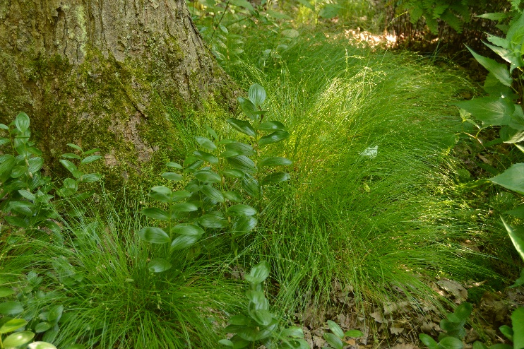
As one would surmise from its native provenance, this species is perfectly hardy, enduring winters from zones 4-8. In fact, I have seen it happily growing in troughs at the Morris Arboretum that remain above ground year-round and undoubtedly freeze solid during colder winters. The pencil thick rhizomes gradually spread and allow the plant to create a dense matt of low growing foliage. Plants are best grown in a shaded or lightly shaded site, although they will tolerate sun for a few hours, especially in the morning or late afternoon. The courser foliage looks great paired with the clump forming Carex appalachica, creating a very naturally appearing composition, as seen in the image above. As with other members of the genus, Dwarf Solomon’s Seal is very drought tolerant and the only damage I have seen is from slugs!
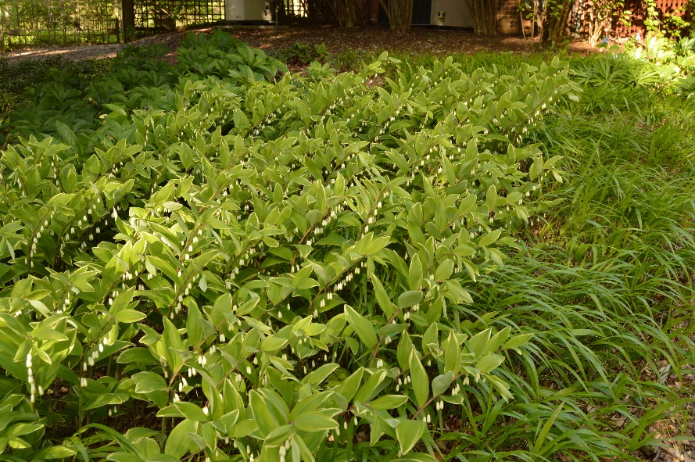
Polygonatum odoratum is another wonderful species with an enormous native region, extending from Europe east to China, Korea and Japan! The species epithet acknowledges the sweet fragrance of the flowers, which also influenced the common name of Fragrant Solomon’s Seal. Interestingly, the plant was originally named Convallaria odorata by Phillip Miller in 1768, 14 years after he published the name Polygonatum! Convallaria is the genus for Lily of the Valley and for a number of years there was great confusion as to which species was properly assigned to which genus! It was not until 1906 that the English botanist George Claridge Druce (1850-1932) assigned the species to the proper genus.
Fragrant Solomon Seal is much taller than the preceding species, typically growing in a slight yet very attractive arching form to 2-3’ tall (as seen above in the variegated form). The stem slightly repeats the zig-zag pattern of the rhizome. The deeply veined foliage appears alternately along the stem and appears much like the wings of a butterfly poised on top of the stem. Leaves grow to 4” long by 1½-2” wide. The flowers are identical to their cousin in form and size but are a somewhat cleaner white, with the reflexed portion of the tepals once again light green. Also similar to their cousin, they prefer woodland conditions, with humus rich soils and protection from the sun during the heat of the day.
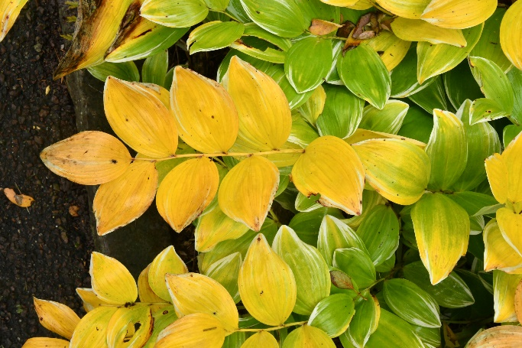
The straight species is rarely seen in gardens, with the variegated selection, Polygonatum odoratum var. pluriflorum ‘Variegatum’ (pictured above), being the most common version of the plant in commerce. The light green leaves are irregularly margined with a clean white border that in mass, looks truly outstanding. To further the drama, the stems are an attractive deep red in color throughout the spring season. The variegation remains attractive and effective throughout the summer into fall. With the colder nights of late autumn, the foliage turns to a buttery yellow from late October into November (pictured at left). ‘Ruby Slippers’ is a green foliaged form that also has very attractive deep red stems. These are outstanding selections where a ‘knee deep’ groundcover is desired.
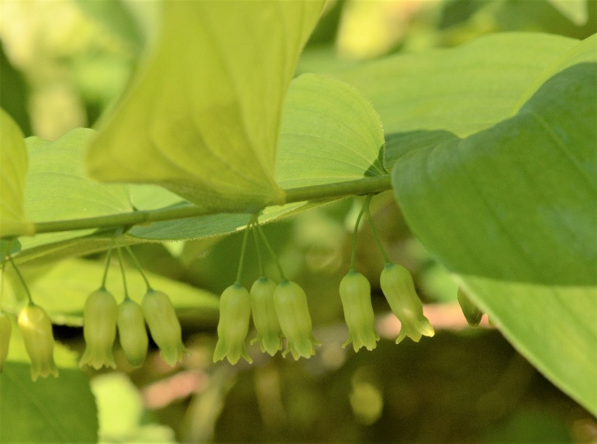
Of course, North America is not to be denied its species of Solomon’s Seal. Polygonatum biflorum is native to the eastern 2/3’s of the US and Canada and is a familiar sight throughout woodlands of NJ. Hardy from zones 3-8, it too was originally misnamed as Convallaria biflora by the American botanist Thomas Walter (1749-1789) in 1788. It was properly named in 1817 by Stephen Elliot (1771-1830), whose vocation was an interesting combination of American legislator, banker and botanist. The species epithet, meaning two flowers is a bit misleading, as the flowers appear in pendulous clusters of 2 to as many as 10 with the petioles originating once again from the leaf axils of the arching stems as pictured at right. Come fall, the flowers are replaced with attractive, ¼” diameter deep blue fruits, beloved by birds and other wildlife. The plants typically grow from 1-3’ tall, although there is a variety or species in North America that grows beyond knee deep, reaching upwards of 7’ tall (pictured below in fall color with fruits). They are typically tetraploid in nature rather than diploid and are usually referenced as Polygonatum biflorum var. commutatum, although the forms also appear as Polygonatum commutatum and Polygonatum giganteum in commerce. One thing is for certain, plant nomenclature remains a science in study!
Regardless of which species you select, you will certainly not be disappointed in how the various species accent and enhance the garden. The gracefully arching stems of the taller species nicely compliment ferns, Hosta and other denizens of the shade, while the Dwarf Solomon’s Seal remains mostly unrecognized for how it can create depth and dimension in a garden. You might say that Polygonatum is ‘knee deep’ in its diversity of garden worthy forms and applications for resolving those design challenges in your garden!
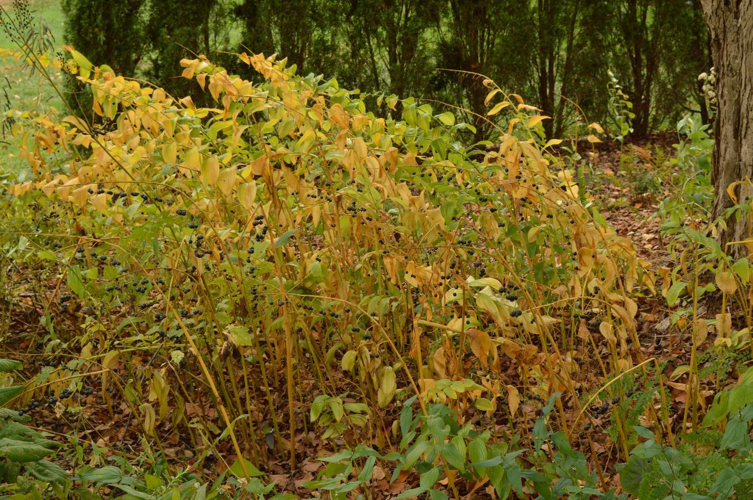
Bruce Crawford
Program Leader in Home and Public Horticulture (NJAES)

