Itea – A Plant in Need of Rediscovery
It is rare for a low maintenance shrub, capable of providing the garden with close to four seasons of interest to be an uncommon plant in the home landscape. Oddly, this is the fate of Virginia Sweetspire and it was not until the late 1980’s that this plant began to gain limited recognition. Indeed, our native Sweetspire, botanically named Itea virginica, seemingly appears to be a ‘late bloomer’ to the gardening world, yet it was a well admired plant in the 1700’s. It appears to have become lost in the wave of new introductions and is a plant in need of rediscovery!
Itea virginica is a member of the Iteaceae Family and contains ten species, nine of which are native to portions of Eastern Asia. The genus name was penned in 1753 by the Swedish botanist Carl Linnaeus (1707-1778) and stems from the Greek Ītéa meaning willow, a reference to its long, willow-like foliage. This also explains another common name of Virginia Willow. The species epithet is an homage to the area in which it was discovered by the plant explorer John Bartram (1699-1777). Bartram lived outside of Philadelphia and traveled extensively throughout Eastern North America, collecting plants and seeds. To help offset his expenses, he often sold plant material and seeds to individuals of wealth in Europe as well as provide specimens for Linnaeus to study. Prior to the plant even becoming officially named by Linnaeus, it was planted in the Garden of Archibald Campbell, the Third Duke of Argyl (1682-1761) in Scotland in 1744 and has been potentially available for gardeners ever since!
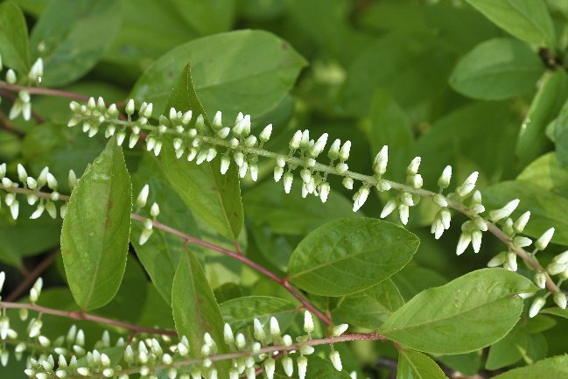
In Bartram’s 1792 plant catalogue, produced by John’s son William, Virginia Sweetspire was described as ‘a handsome flowerg shrub’. Granted, the spelling may not reflect current standards, but the description is most appropriate. Itea virginica is a multistemmed, suckering shrub, growing naturally in moist to wet soils along streams, ponds and in Pine Barren communities. It is native from southern NJ south to Florida and west to the Mississippi River Valley and southern Illinois. In sunny locations, the plant forms a dense thicket with the stems growing to 4-6’ tall and the suckering rootstock slowly spreading to a width of 8-10’. In shaded sites, the plants are far less dense and can stretch to upwards of ten foot tall. Typically, the stems display reddish tones during winter, adding a much needed splash of color against a blanket of snow.
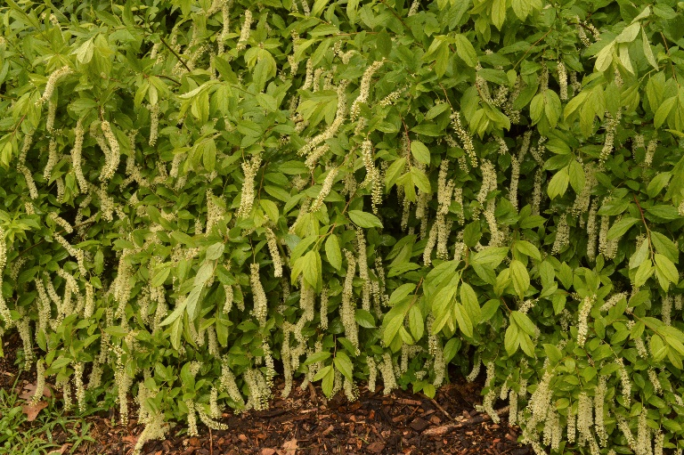
Come spring, the plants slowly leaf out in early May with the foliage initially a light green in color before developing a deeper green tone come summer. The foliage is usually linear to elliptical, measuring ¾-1” wide by 1½-4” long and tapered at either end, resembling a large willow leaf. Starting in late May through mid-June, numerous short leafy stems give rise to 3-6” long by ⅝” diameter pendant flower racemes, each radially clothed in ½ inch diameter, 5 petaled flowers. The racemes are ornamental when the flowers are even in their bud stage (as seen at right), but they really shine when they open fully. As the common name of Sweetspire implies, the white flowers are lightly and pleasantly fragrant and last for close to 3 weeks. Although authorities often vacillate on the impact of the floral display, when the plant is used in mass in bright shade or a sunny location I find the effect to be intoxicating, as seen at right!
The flower buds develop on stems produced the previous year and any pruning to reduce the plant’s size is best completed immediately after flowering to prevent the removal of flower buds. Fortunately, pruning is usually not needed outside of the occasional removal of an older and declining stem in winter. If for some reason you wish to renew a colony, cutting the clump to the ground in late winter is best, although that will also eliminate the flower display for the coming year. Come mid to late October, the deep green foliage develops into a breathtaking bright red to reddish purple fall color that usually persists well into December. When paired with a plant displaying golden yellow fall color, such as Amsonia hubrichtii the impact is truly outstanding!
Although Virginia Sweetspire is normally found in moist soils in shaded environments, the plant is amazingly tolerant of varying conditions and will thrive in full sun in soils with average drainage. It is also very pH tolerant, growing well in soils from 5.0 to near 7.0. Once pH levels edge above 7.0, the leaves often become chlorotic and are marked by the appearance of dark green veins and light yellow foliage. Plants are typically hardy to zone 6, although some forms grow best in zones 7 or warmer.
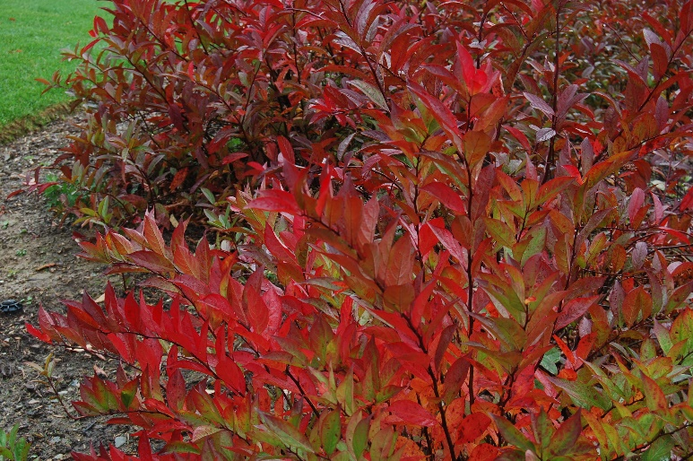
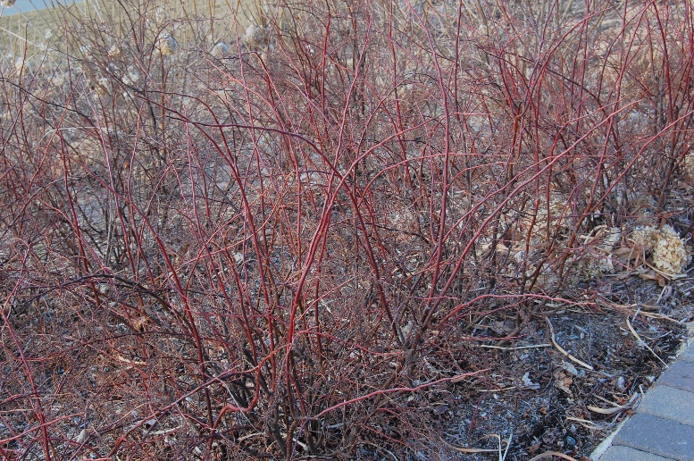
One of the most attractive and hardy selections has proven to be ‘Henry’s Garnet’. Henry refers not to a man’s first name, but to Mrs. Mary G. Henry, Founder of the Henry Foundation for Botanical Research. She found the plant near Sharpsburg Georgia in November of 1954 and was struck by the stunning fall color (as seen at left) that persisted well into winter. The plants also have a more compact habit, typically growing to a height near 4’ with a good floral display. Normally, plants from more southern provenances are marginally hardy in NJ, but this plant has proven to be among one of the hardiest forms, easily surviving temperatures of -15 degrees Fahrenheit. Come winter, the younger stems develop a deep red color on the sunny, southwestern side and green to brown shades on the remaining portions (as seen below). The plant was distributed by the Arnold Arboretum in 1980 as an unnamed plant dividend, and it was not officially named until 1984 by Judy Zuk. At the time, Judy was the Director of the Scott Arboretum of Swarthmore College and was admiring a specimen of the plant at the arboretum. Rightfully believing it to be worthy of cultivar status. She combined Mary’s last name with the official school color of Swarthmore, Garnet, and the name was born! The plant became commercially available in 1985 when Woodlanders, a mail order nursery in Aiken South Carolina first offered it to the public. It has since attained the Gold Medal award from the Pennsylvania Horticulture Society’s in 1988, proving Judy’s intuition was correct.
Since then, numerous other selections have hit the market. ‘Merlot’ has wine red fall color while ‘Long Spire’ has somewhat longer flowers up to 8” long with a yellow orange fall color. Little Henry® has is a more compact habit, growing to 3-4’ tall, but has also proven to be marginally hardy for NJ gardens.
The only other species that is hardy for NJ gardens is Itea japonica. Named in 1831 by the Czech botanist Karel Bořivoj Presl (1794-1852), the plant is much like its North American cousin and is native to moist woodland regions of Japan. Similar in size, flower and fall color as Itea virginica, it is also the subject of an interesting plant collecting story. In 1955, Dr. John Creech (1920-2009), who became the Director of the National Arboretum was collecting plants on the island of Kyushu, Japan. During the trip he collected cuttings from what he thought to be Itea japonica, which were ultimately shared with the Arnold Arboretum. Dr. Gary Koller of the Arnold was intrigued by the plants compact 3-4’ habit, as well as its ability to develop a dense thicket and named it ‘Beppu’ in honor of the town from which it was collected. It has since been determined that the plant is in fact Itea virginica which was shared with Japan during the late 1800’s! If nothing more, having this plant in your garden will provide a Sweetspire with attractive reddish purple fall color and a truly fun and innocent story to share with friends.
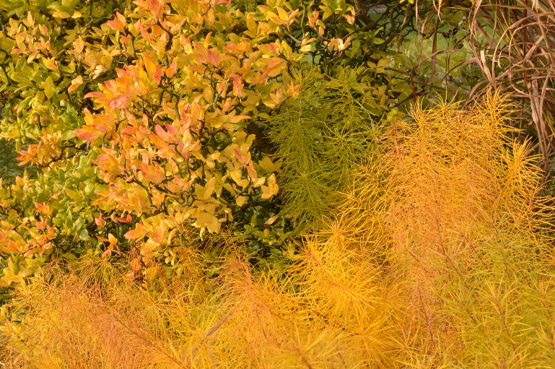
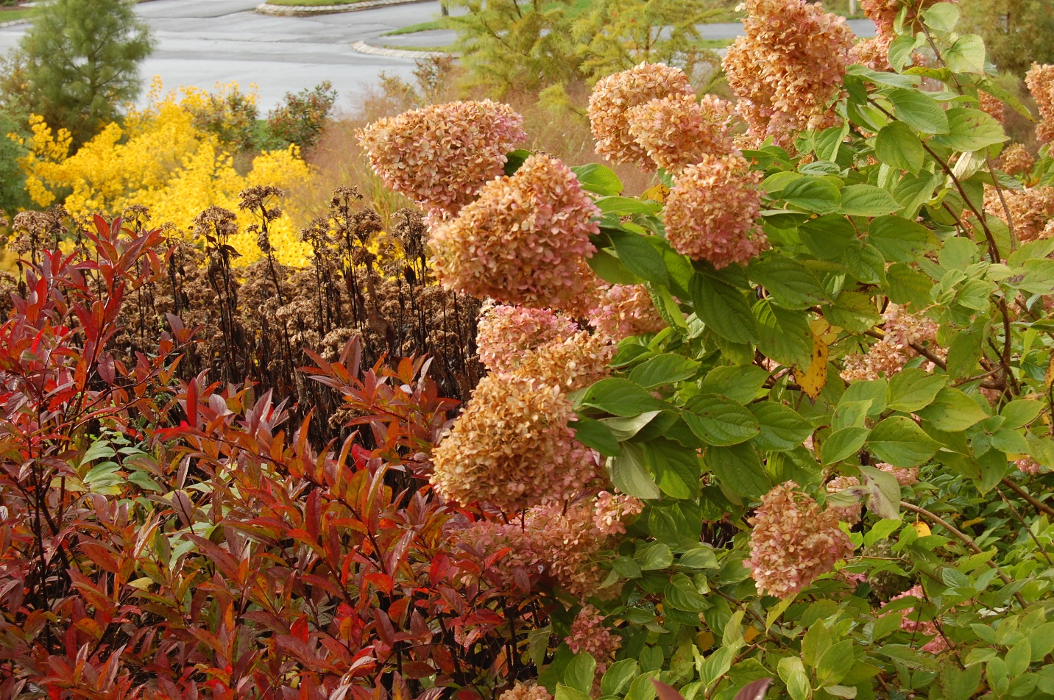
Virginia Sweetspire looks wonderful in mass and makes a great companion planting for plants with red autumn fruits like Winterberry Holly (Ilex verticillata), pink flowers plumes such as Dallas Blues Switch Grass (Panicum virgatum ‘Dallas Blues’) or Hydrangeas with pink autumn flowers like Hydrangea paniculata ‘Limelight’ as seen below. Its arching habit makes it a great plant for bringing your eye from taller plants down to the ground plane or for planting along walkways. And, it always provides a nice compliment for plants with good yellow fall color such as the previously mentioned Amsonia or Flying Dragon Hardy Orange (Poncirus trifoliata ‘Flying Dragon’), both of which are pictured above at left. As you study your garden ‘bones’ this fall and winter, contemplate how this plant might be able to enhance your garden. It may be a ‘late bloomer’ to modern day gardeners, but it is a plant most worthy of rediscovery!
Bruce Crawford
Manager of Horticulture, Morris County Park Commission

