The Mighty Onion – A Gardeners Friend
Onions are a plant most people consider as an ideal addition for the vegetable garden, while the more ardent gardeners undoubtedly recognize their potential for colorful spring bulb displays. The selections many people have yet to discover are the species and crosses available for late summer and autumn bloom. Indeed, the mighty Onion, botanically known as Allium has much to offer the autumn garden!
Allium is a huge genus and often the differences between the various species are barely discernable, which explains the range in potential species from 250 to over 950. Once considered a member of the Lily Family, it is currently assigned to the Amaryllidaceae or Amaryllis Family with the majority of the species found in temperate regions throughout the northern hemisphere. The name Allium is Latin for Onion and was officially ascribed to the genus by the Swedish botanist Carl Linnaeus (1707-1778) in 1753 when he established cultivated garlic, Allium sativum as the type plant for the genus. The species epithet of sativum is from the Latin for cultivated. Allium species are characterized by growing from an underground structure of modified leaves called a bulb. In some species the bulb forms at the end of a rhizome or horizontal root while a few species have tuberous roots composed of modified stems. The bulbs, along with the foliage and flowers contain strong aromatic compounds containing sulfur, providing the characteristic fragrance of garlic. They are also characterized by flowers in the form of umbels, whereby the individual floral stems or pedicels radiate outward from a central point like a starburst. The pedicels are often all of equal length, but not always. The flowers are typically campanulate or bell-shaped and are composed of 6 tepals in which the 3 outer sepals of the calyx and 3 inner petals of the corolla look virtually identical, with all 6 serving to attract pollinators.
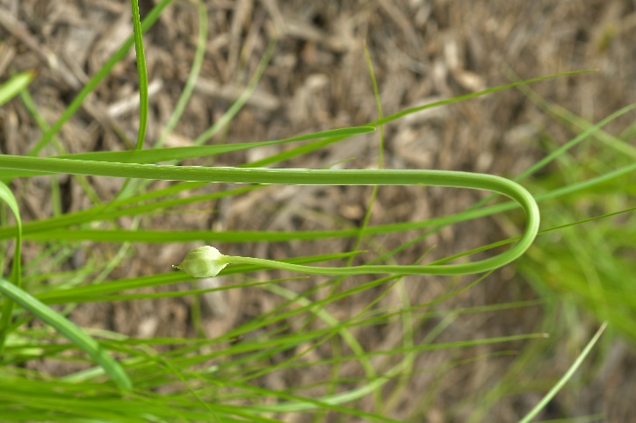
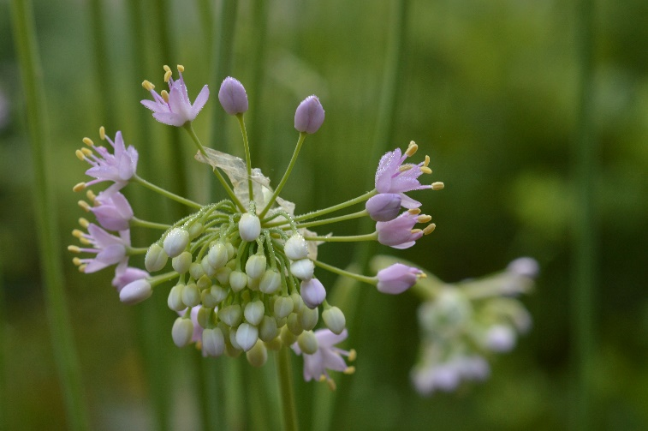
One interesting species that is native to much of the United States, northern regions of Mexico and parts of Canada is Allium cernuum or Nodding Onion. It was named and described by the German Physician and Botanist Albrecht Wilhelm Roth (1757-1834) in 1798. The species epithet is from the Latin meaning ‘face turned towards the earth’ or ‘stooping’, a physical attribute also echoed in the common name. The foliage appears as open clumps of flat, grass-like leaves growing to 10-12” long and persisting throughout the growing season. The flower stem begin to appear in mid-July. It is initially rather limp in appearance (as seen at right) with the upper half of the stem completely bent over and the flower bud facing downward, a stature befitting of its botanical and common names. As the flower nears the point of opening in late July and August, the floral stem ‘unrolls’ upwards until all but the flower bud is standing upright. The leafy outer covering to the flower bud called the spathe splits open as the bud begins to make its final rise upwards, allowing the individual flowers to tumble outwards, as seen below right. When the flower is finally upright, the flowers radiate outward in the characteristic ball shape of an umbel. Very dramatic for a flower that is only 12-18” tall! The 1/8” diameter flowers are pink, lavender and occasionally white in color, with upwards of thirty to forty individual flowers per umbel. In mass, they create quite the impact and look great mixed with low sedges and other grassy foliaged plants. The flowers are beloved by pollinators and effective for several weeks, following which each flower develops small black seeds that allows the plant to rapidly naturalize in the years to come. The seedlings can become weedy and in small garden areas it may prove beneficial to deadhead the flowers. The plants naturally occur in rocky soils in open woods, dry meadows and prairies, where their spreading nature is actually very becoming.
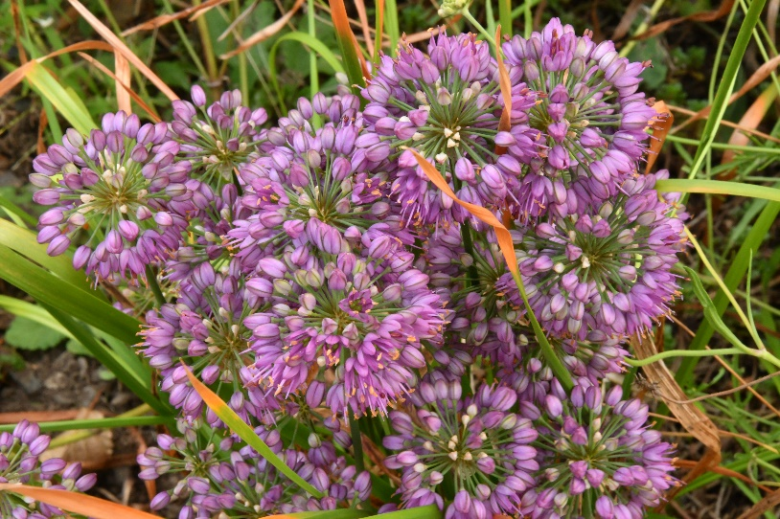
Blooming slightly later is Allium thunbergii, the Japanese Onion. Native to Japan, Korea and coastal Eastern China, this species normally blooms in September into October in NJ. The foliage is once again grass-like, stretching to 12” tall with numerous 1½” diameter rosy purple umbels floating above to heights of 15-18”. Once the blooms fade the floral impact continues to be of interest well into winter as the stems turn to orange while the seed heads retain a distinct pink coloration. They look remarkable with a dusting of snow, as seen in the image at the article’s end. The plant was originally named Allium odorum in 1784 by the Swedish naturalist and physician Carl Peter Thunberg (1743-1856), from specimens he collected during his visit to Japan during 1776. The Scottish Botanist George Don (1798-1856) thought this name to be rather ambiguous, since all species of Allium are odiferous and renamed the plant to honor Thunberg in 1827. Don was greatly intrigued by the genus and published a monograph on Allium several years later in 1832. The selection that is currently most available in the trade is ‘Ozawa’ (as seen above). It was introduced by author and nurseryman George Schenk of Washington State and offers a slightly shorter stature than the species with larger, 2-2½” rosy purple flowers. On the outer surface of the tepals is a central dark green to purple line that provides added interest on close inspection.
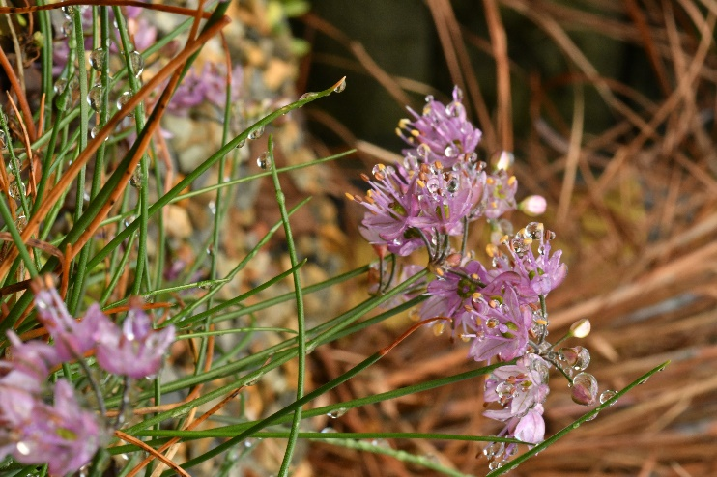
Blooming later yet is Allium kiiense or Kii Garlic that is still in bloom in the middle of November and able to tolerate 16 degrees of frost without any visible impact on its display. Originally named Allium virgunculae var. kiiense in 1952 by the Japanese botanist Gen Murata (1927-2020), the name was changed in 2009 since the flowers fail to form spherical umbels, but only project outward horizontally, as if the flower buds only formed around the equator line of a globe. With such small differences, it is easy to see how there is such a range in the potential number of Allium species! The plant is native to the Kii Peninsula on the island of Honshū Japan, along with the nearby prefectures of Gifu, Aichi and Yamaguchi. The flowers are rosy pink with a green central rib down the outside of the tepals. The flowers are far less numerous than the previous species, averaging around 10 per umbel. However, the individual flowers are also larger than those of its cousins, reaching ½” in diameter when open, allowing a small clump to provide a nice splash of late autumn color. The numerous 6-8” tall floral stems are produced over the very slender, round grassy foliage of roughly the same length, although it rarely arches above 3-4” tall. The foliage is evergreen, usually assuming attractive red tones throughout the winter. With few people shopping while it is in bloom, this species will most likely never become mainstream. However, for the garden it is hard to beat the late season color and it is a great addition for rock gardens or other well-drained locations. I have yet to see any seedlings develop, as the seeds may not mature in NJ before the onset of winter.
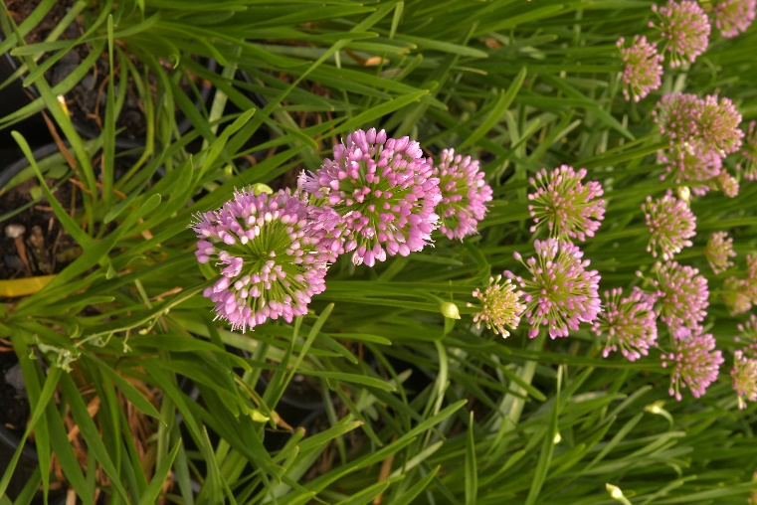
Aside from these species, there are numerous hybrids on the market that also provide the garden with late summer color along with great flowers for pollinators. Probably the most recognized is Allium ‘Millenium’ (pictured at left), the Perennial Plant of the year for 2019. In case you were wondering, ‘Millenium’ is the proper spelling with one ‘n’ and is the result of the breeding efforts of Mark McDonough, an architect by trade who has been fascinated with this genus since High School! The selection was introduced in 2000 through Plant Delights Nursery. The parents include Allium nutans and Allium lusitanicum, with the flattened appearance of the foliage stemming from the Allium nutans parent and the dark green from Allium lusitanicum. The foliage grows to 10-15” tall. Each bulb produces 2-3 flower scapes, with each scape topped by a 2” diameter, deep rose purple umbel. The attractive floral display lasts for upwards of 4 weeks and the flowers are also a favorite among pollinators. Although rare, seedlings have been known to occur.
Another good Flowering Onion for late summer is Allium ‘Pink Planet’, as seen below at right. Offering pink flowers that may not be planet sized, but with diameters upwards of 3” it is one of the largest August into September blooming forms. The umbels have pale lilac or pink coloring and once again remain very popular with the pollinators. There is a nice separation between flowers and foliage, with flowers stretching to 18” tall above the 8” tall foliage. The plants also display vigorous growth with the clumps slowly spreading to 2’ across over 10 years. It produces few if any seedlings and the dried flower heads look great against winter snows.
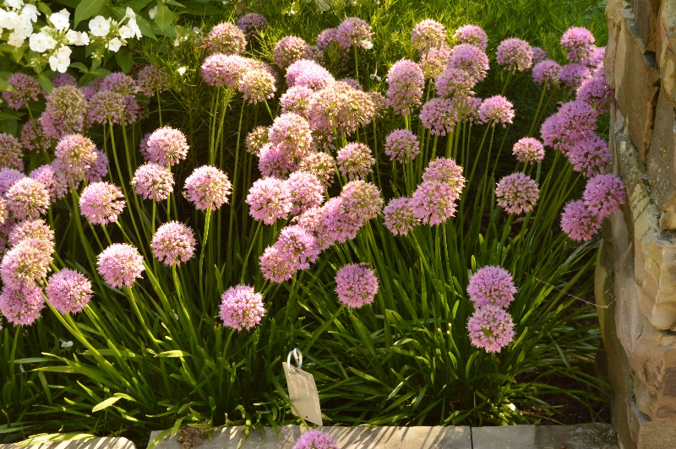
All these Allium species and crosses prefer well-drained soils in full or afternoon sun. Allium thunbergii ‘Ozawa’ is very adaptable and will tolerate moister soils, although it may have difficulty outcompeting the weeds in moist locations and remains best grown in drier conditions. Due to the hybrid vigor, ‘Millenium’ and ‘Pink Planet’ are ideal for use as an edging plant or used in mass, complimented with spiky flowered plants like Russian Sage (Perovskia atriplicifolia) or small to mid-sized ornamental grasses. Allium kiiense is best in a gravel scree where the low mounding foliage will not be overwhelmed with taller plants and its evergreen nature can best be appreciated. With its heavy seeding nature, Allium cernuum is best located along a woodland edge or in low sedges where it can freely naturalize.
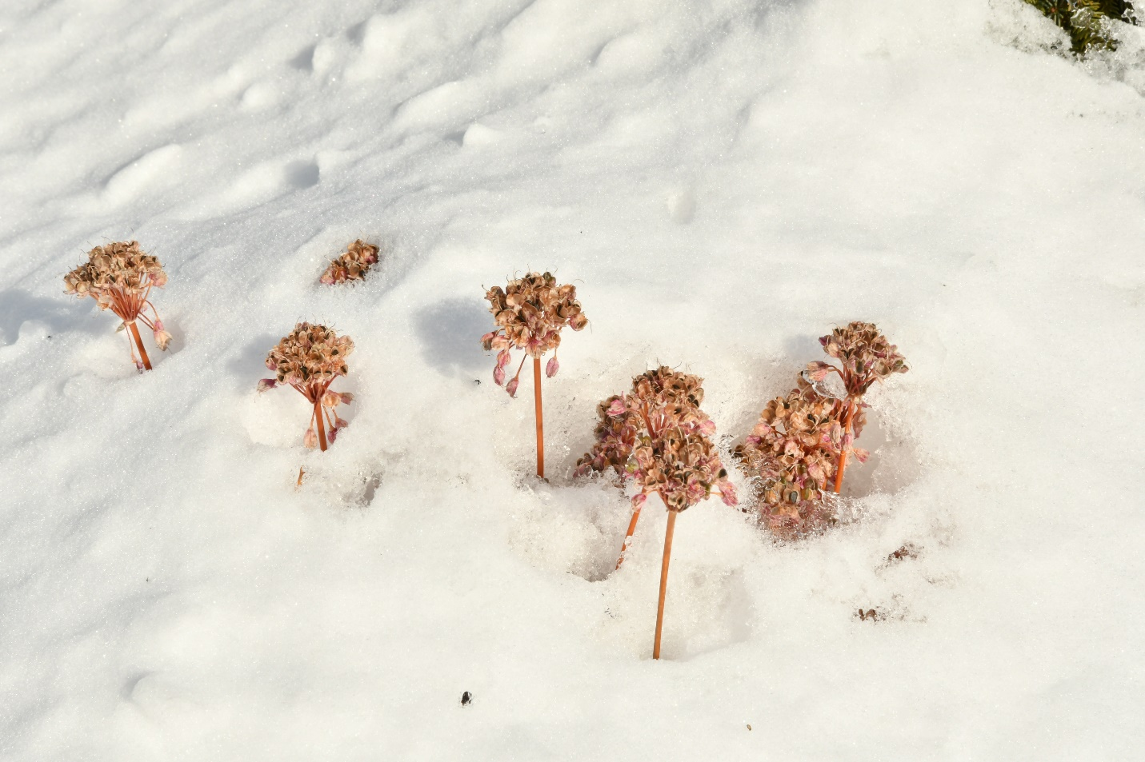
Without doubt, the mighty onion is a genus that can equally serve many functions. I could not imagine eating cottage cheese without a handful of chopped chives or having the harlequinesque blooms of the spring blooming selections in a mixed border. Yet, it is the more delicate species and robust hybrids of late summer and autumn that help to carry gardens into winter as Allium thunbergii ‘Ozawa’ illustrates below. Without doubt, the Mighty Onion is a gardener’s friend.

Bruce Crawford, Program Leader in Home and Public Horticulture, NJAES

