An Evergreen for Winter Structure and Beauty
Everyone views evergreen plants from a different point of view. Some prefer most of their garden to consist of unusual and colorful evergreen shrubs, providing a more consistent appearance throughout the year. Others prefer evergreens to serve as the slender backbone of a garden, providing winter structure through foliage and form while allowing other plants to take center stage throughout the remainder of the year. I must admit, I am a member of the latter philosophy of design and the palette of evergreen plants for providing this winter backbone is substantial. However, with its glossy deep green foliage, Plum Yew or Cephalotaxus as it is botanically known has rapidly become one of my favorite evergreens for the winter garden.
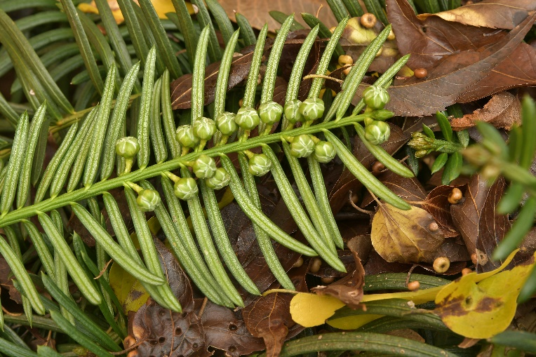
Despite its many virtues, Cephalotaxus is still an uncommon selection for gracing winter gardens. At one point it was classified under its own family of Cephalotaxaceae, before molecular analysis relocated the genus within the Taxus family or Taxaceae. Currently the 11 existing species are native to Eastern Asia, however this was not always the case. Fossils have been found in NW North America and in Europe dating back to around 20 Million Years Ago (MYA) and in Greenland dating to the later Jurassic Period or around 145 MYA! The term Cephalotaxus was first coined by the German Botanist and Physician Philipp Franz von Siebold (1796-1866) during an extended visit to Japan from 1823-1829. The word comes from the Greek Kephale for head, describing how the ⅛” diameter male flowers or cones loosely bear a resemblance to a human head combined with the how the foliage resembles that of Taxus or Yew. Of course, appearance is all in the eye of the beholder, since I find the cones to be more reminiscent of tiny Brussel Sprouts as seen above!
Although Siebold initially discovered the plant, he worked in partnership with the German botanist Joseph Gerhard Zuccarini (1797-1848) to publish the multitude of plants he discovered in Japan. In 1835, the initial version of their book Flora Japonica was published, including the first yet improper description of Cephalotaxus. It was not until 1842 that the genus was properly described by the Austrian botanist Stephan Friedrich Ladislaus Endlicher (1804-1848).
Siebold sent the first samples back to Europe during 1829, shortly after he departed Japan. Interestingly, the plants Siebold sent back to Europe turned out to become the most popular ornamental species of the genus and rapidly caught the eye of the 4th Earl of Harrington, Sir Charles Stanhope (1780-1857) who incorporated the plant into a garden at Elvaston Castle. It also caught the eye of several British gardeners who love to peer over garden walls to see what novelties their neighbors have planted! The British gardener Joseph Knight (1778-1855) initially named the plant Taxus harringtonia in honor of the Earl’s appreciation for the plant. Of course, Knight did not follow proper protocol in describing the plant so it was republished properly, albeit once again under the same improper genus by the British Gardener and botanist James Forbes (1773-1861) who is remembered for Chionodoxa forbesii. Finally, the German botanist Karl Heinrich Emil Koch (1809-1879) correctly placed this species under Cephalotaxus in 1873! In 2012, the species epithet was updated according to the rules of nomenclature, leading to the current species spelling of harringtonii.
In its native habitats of Japan, the Plum Yew varies in size from low spreading forms as seen along cliffs boarding the Pacific Ocean and upland mountainous regions to those reaching more arborescent heights of 30’+ with comparable widths. Most of the plants appear in woodland areas where they flourish in deep, humus rich soils. The lustrous, dark green and waxy foliage ranges from ¾”-2” long and is retained by the plant for 3 years, a period consistent with evergreen conifers. The bottom of the foliage is light green and features two lines of silvery stomata running the length of the leaf. Although the foliage is actually arranged radially around the outstretched horizontal stems, the petiole at the base of the leaf twists the leaf in such a manner as to allow the foliage to appear in a planar arrangement on either side of the stem. Most likely, this orientation evolved to allow the foliage to be oriented towards the sun, improving the efficiency of photosynthesis. In bright light or full sun, the leaves arch upwards, creating a V-shaped appearance much like the appearance of a birds’ upwardly arching wings in flight. In shade, the leaves become more planar, once again allowing more sunlight to reach the entire upper leaf surface.
Characteristic to nearly all species of Cephalotaxus, the plants are dioecious whereby some plants produce only male cones while the remainder yield only female cones. Occasionally, it is possible to find a monoecious plant, with both male and female flowers borne on the same plant. Although this is intended to prevent inbreeding via self-pollination, it is currently serving to the detriment of the species in the wild. Typical of all conifers, the flowers are wind pollinated. As the number of plants decline in Asia due to farming and other human activities, the area between plants expands. This increased distance makes it less likely for pollen to drift far enough to reach a female cone and the chance for seed production is diminished.
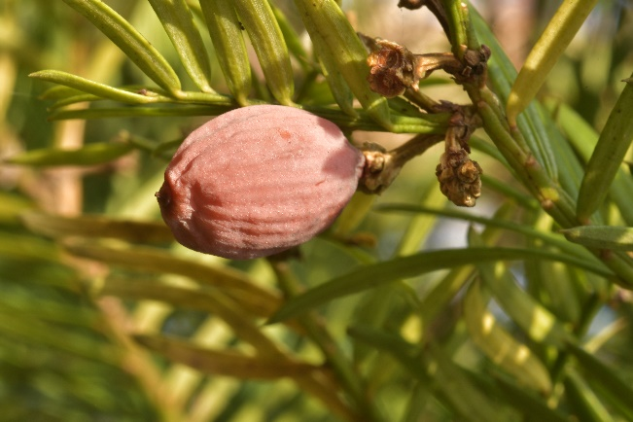
The cones of evergreens may not necessarily be pretty, but they are often very interesting. The ⅛” diameter male pollen releasing cones appear in the leaf axils along the drier and protected undersides of a stem. The green orbs appear during early fall on the growth of the previous summer. Come April and May, they transition to light cream while pollen is shed and finally to dark brown when they senesce. The female cones rarely appear solo, but rather in clusters of 6-12, supported by short stems. As is also true to most conifers, the female cone or ovule requires upwards of 18+ months to mature. For Cephalotaxus, the small female cone consists of oppositely arranged bracts or modified leaves, with each bract having two ovules. Typically, only one or two ovules develop per cone, with the developing seed covered by a hard shell and a fleshy outer coating that is thought to develop from a pair of fused swollen leaves. The fleshy coating transitions from green to pink to finally a dark purplish brown (as seen above) as the seed matures and gives the seed an olive or plum-like appearance at maturity. It is also these seeds that prompted the common name of Plum Yew! The fleshy coating attracts squirrels, birds and other animals, which serve to move the seeds to new locations to germinate. It is rare for seedlings to appear in a home garden setting, but in Arboreta where the plants have been established for decades it is not uncommon for seedlings to appear, often a considerable distance from the parent plant. However, the plant is far from what would be considered invasive.
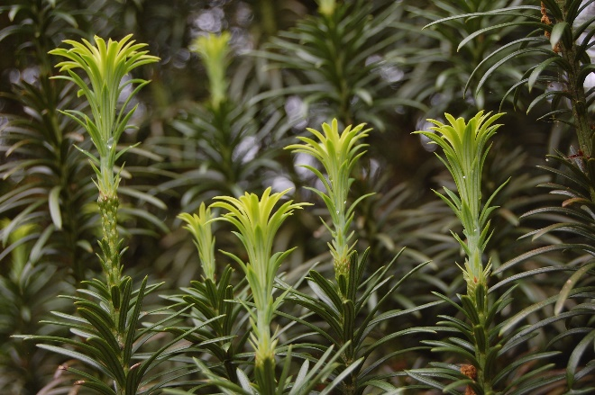
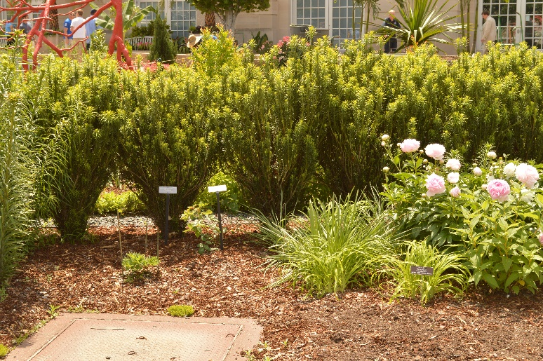
In cultivation the compact and spreading forms of Plum Yew have taken precedent over the larger shrub and small tree forms. One exception is the form named ‘Fastigiata’ that has retained popularity since first being introduced from Japan during 1861. In youth, the plant is distinctly upright in shape, maintaining widths near 12” when the plants are 3-4’ tall. With time, the plant gradually develops into a broadly spreading or nearly globous form, approaching heights of 18-20’ with equal widths. The interesting part to its growth is how the upward reaching stems emerge from a constricted, waist-like trunk at the base. Overall, the plants have an appearance reminiscent of a bouquet of flowers where the base is tied together with a rubber band. I have seen several hedges crafted from this plant, but if the plants are not located tightly together, the pinched appearance at the base does not permit a solid and dense hedge to develop, as seen above. There are exceptions and at Chanticleer Gardens in Wayne PA, several plants were grouped tightly together and with some judicious pruning, the plants have retained a full and attractive upright habit (as pictured at the end of the article). The foliage of this selection is unique, since unlike other forms I have seen, the foliage found on the upper stems reveals the whirled arrangement of the foliage, with the needles assuming a radial arrangement around the stems, as seen above at right. Interestingly, it is not uncommon for short yet randomly growing shoots to appear near the base, which have the foliage arranged in the more typical two-row orientation. I have yet to see male or female cones on this form. The selection ‘Korean Gold’ is a gold variegated form of ‘Fastigiata’ with the variegation most prominent on new growth in spring before gradually fading to green. Introduced from Japan by Mr. Barry Yinger, the plant needs to be carefully sited in part shade since full sun will make it appear rather garish.
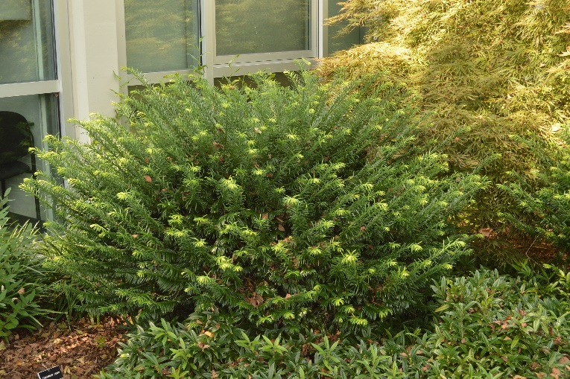
In 1958 Richard H. Fillmore, who served as the superintendent of Sarah P. Duke Gardens in Raleigh NC from 1956-1975 and the Director from 1975-1977, selected a very attractive sport that had appeared near the base of an aforementioned ‘Fastigiata’. It had been growing for well over 10 years and by 1958 it had developed into a soft ‘fan-shaped display’ in excess of 5 feet in diameter and was a sport of exceptional beauty. Fillmore named it ‘Duke Gardens’. Similar to the parent plant, the dark green foliage assumes a more whirled or radial configuration around the stem. Although reports of the size of the plant vary considerably, from personal observations at Sarah P. Duke Gardens and the Scott Arboretum (as pictured above), it grows to 3’ tall and upwards of 6-8’ wide. As the stems grow upwards they lightly arch under their own weight, maintaining the shorter and broader habit. The size and density of the plant is undoubtedly more compact in full sun than in shade. This is a great landscape form that I have seen thriving in zone 5 regions of NJ without any issues after 15 years of growth.
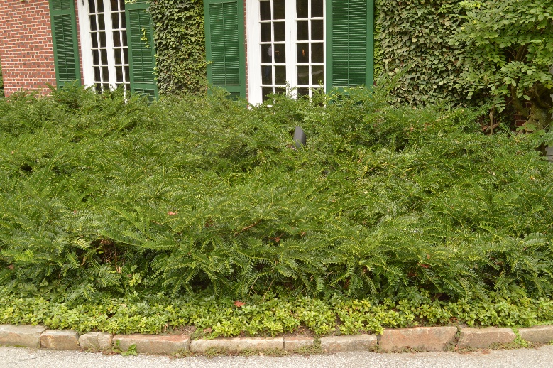
Another commonly available form is ‘Prostrata’, as seen growing in full sun at left in Longwood Gardens. As the name implies, it is a prostrate or horizontally growing form with a more sprawling form than ‘Duke Gardens’. Unfortunately, it has proven to be problematic in the trade since many of the selections sold under this name are cuttings taken from the horizontal side growth of upright growing plants. These cuttings have a ‘memory’ of the horizontal growth and the genetics of the true form of the plant may remain quiescent for upwards of 30 years after being propagated. Once the plant finally ‘recalls’ its original identity, it assumes the true form with one to many upright leaders developing. The true ‘Prostrata’ is a spreading form with gracefully arching new growth that can reach 3-4’ tall and well over 10’ wide with time. Customary to the species, the growth is more lax and open in shaded locations as compared to sunny.
The last form that is prevalent in the trade is the variety Drupacea. When Siebold shipped the first plants from Japan, he named it Cephalotaxus drupacea. The name stems from the Latin drupaceus, meaning ‘drupe like’. Just as female cones served as the inspiration for the common name of Plum Yew, they also inspired this varietal name. Fruits such as plums that contain a single large seed surrounded by a fleshy coating are botanically termed a ‘Drupe’, hence drupacea! The challenge with this variety is the number of variations that appear in the trade. Technically, this variety is a male with foliage appearing as two rows along the branch with each leaf having a more distinctive, upright arching form. Unfortunately, there is once again confusion with some forms having a whirled foliar arrangement and the size of the plants vary from almost tree-like to low growing, spreading forms. By most authorities, this selection is supposed to offer more compact growth, yet ultimately grow into a large shrub of 12-18 feet.
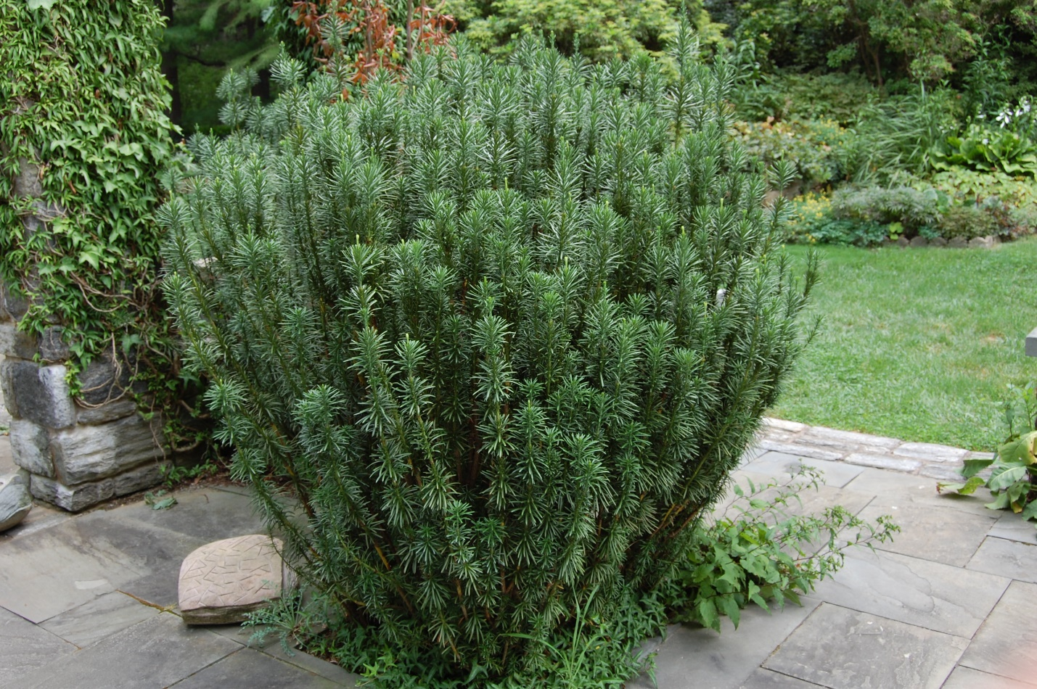
All the selections mentioned above have proven to be very cold tolerant, enduring -10 Fahrenheit temperature accompanied by winds with none to only slight burning of the foliage. Ideally, the plants should receive morning sun and protection from afternoon sun. However, I have had great luck with growing these plants in full sun. Furthermore, much unlike their closely related cousin Taxus, Cephalotaxus has proven to be highly resistant to deer browse. A huge bonus for most gardeners! The lower growing forms look great when massed, although they are also attractive when grown individually. As you examine your garden with a critical eye this winter, consider whether it is in need of some evergreen bones for structure and beauty. If so, you may wish to consider some masses of Plum Yew to carry your garden through the winter doldrums!

Bruce Crawford
Manager of Horticulture, Morris County Park Commission

